BDS SHROPSHIRE AND WORCESTERSHIRE AREA 27
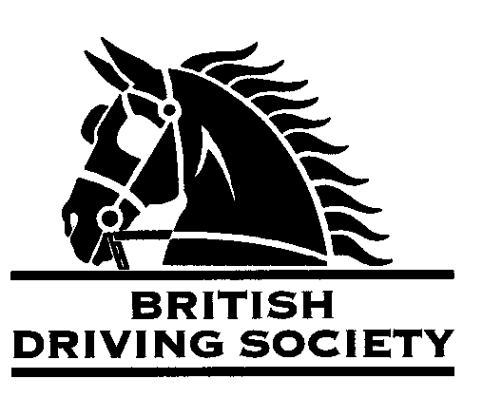
EVENT:May Day drive followed by bring your own picnic.
Short route 12 miles. Long route 18 miles.
Horses must be vaccinated for this drive.

VENUE:Chadwell Grange, Newport The drive is held by kind invitation of Mr Richard Maddocks.

POST CODE:TF109BG

Date: MONDAY 6th May 2024.
ENTRY FEE: £5.00
TIME:10.30am

Maps and full instructions will be given at the commencement of the drive.

All drivers and participants must agree to abide by the Rules of the British Driving Society available at www.britishdrivingsociety.co.uk.

Correctly fitted hard hats that meet the latest safety regulations are recommended and are mandatory for participants under the age of 14. All drivers must be aged 8 years or older and all participants under 18 must be accompanied by a responsible adult.

CLOSING DATE FOR ENTRIES….......... 29TH APRIL 2024……………………………………………………

----------------------------------------------------------------------------

Entry form for Event: MAY DAY DRIVE 6TH MAY 2024

NAME………………………………………………………………………………………………………………………………………………………

ADDRESS………………………………………………………………………………………………………………………….......................

…………………………………………………………………………………………………………POST CODE…………………………………

TELEPHONE No…………………………………………........MOBILE…...................………………………….

Email………………………………………………………………………………………………………………………………….......................
I am a B.D.S. MEMBER, Membership No. …………………………..…………………………………..…………………...

Payment enclosed……………………………………………………………..(cheque payable to BDS Shropshire)
My horse is/is not vaccinated against Equine ‘flu (PLEASE COMPLETE)

SIGNED…………………………………………………………..PRINT NAME………………………………………………………..

Please return this slip with your cheque by 29TH APRIL 2024 to:
Mrs F. Stubbs, Birch Tree Farm, Knightley, Stafford.ST20 0JN.
Contact details 01785 284140, stubbsfelicity@gmail.com, 07572 156438

