BDS SHROPSHIRE AREA 27
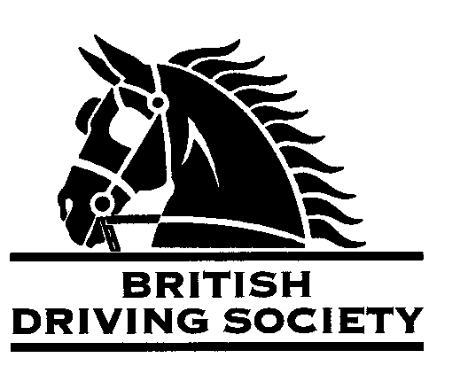

EVENT Bill Friswell Memorial Drive. Approximately 10 mile drive kindly organised by Tom Friswell who may be contacted on 07975 884108 or tom.fris@hotmail.co.uk
Tea and cakes afterwards; bring your own lunch and a chair.

VENUE Richard’s Castle Memorial Hall, Richard’s Castle, Ludlow SY8 4EQ.

DATE 28th April 2024

TIME 11am

ENTRY FEE £5

Maps and full instructions will be given at the commencement of the drive.

All drivers and participants must agree to abide by the Rules of the British Driving Society available at www.britishdrivingsociety.co.uk.

Correctly fitted hard hats that meet the latest safety regulations are recommended and are mandatory for participants under the age of 14. All drivers must be aged 8 years or older and all participants under 18 must be accompanied by a responsible adult.

CLOSING DATE FOR ENTRIES Tuesday 23rd April 2024

---------------------------------------------------------------------------------------------------------------------------------------------

Entry form for Bill Friswell Memorial Drive, 28th April 2024

NAME

ADDRESS

POST CODE

TELEPHONE No MOBILE

Email _

I am a B.D.S. MEMBER, Membership no._____________________________________________________________

Payment enclosed (cheque payable to BDS Shropshire)

Payment online to Lloyd’s Bank, sort code 30-96-26, account number 80118660
British Driving Society-Area 27 Shropshire

My horse is/is not vaccinated against Equine ‘flu (PLEASE COMPLETE)

SIGNED _____________________________________________________________________________________

Please return this slip with your cheque by 23rd April 2024 to:

Tom Friswell, The Batch, Eardisley, Herefordshire. HR3 6PP. 07975 884108 or tom.fris@hotmail.co.uk

