BRITISH DRIVING SOCIETY, SHROPSHIRE AREA 27
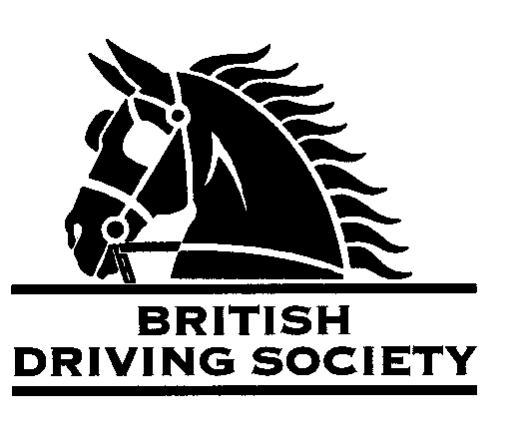
EVENT:

RODINGTON SPRING DRIVE FOLLOWED BY BRING YOUR OWN PICNIC.

VENUE: YARD NEXT TO THE BULL’S HEAD, HUNKINGTON LANE, RODINGTON WITH HALFWAY HALT.
Long route approx. 12 miles on quiet lanes, shorter route available
POST CODE:
SY4 4QS

DATE: SUNDAY
14th April 2024
TIME: ARRIVE 10.00AM LEAVE FROM 10.30AM SINGLY OR IN GROUPS LAST AWAY 11.30AM

ENTRY FEE:
Member £5

Maps and full instructions will be given at the commencement of the drive.

Neither the Organizing Committee, nor the British Driving Society, nor any Landowner, nor any Agent, Employee or representative of these bodies accept any responsibility for any accident, loss, damage, injury or illness to any animal, person or property whatsoever, however caused.
The Society takes reasonable precautions to ensure the Health and Safety of everyone present at each event. For these measures to be effective, everyone must take all reasonable precautions to avoid and prevent accidents occurring, and must obey the instructions of the Organizer and all Officials and Stewards.

All drivers and participants must agree to abide by the Rules of the British Driving Society available at www.britishdrivingsociety.co.uk.
Individuals should comply with Government Guidelines regarding Covid 19 in place at the time. Hand sanitiser & wipes to be carried.
Individuals who are symptomatic or have been exposed to the virus should not attend.
Correctly fitted hard hats that meet the latest safety regulations are recommended and are mandatory for participants under the age of 14.
All drivers must be aged 8 years or older and all participants under 18 must be accompanied by a responsible adult.

CLOSING DATE FOR ENTRIES ……1ST APRIL 2024………………………………………..

Entry form for Event: RODINGTON SPRING DRIVE ON 14TH APRIL 2024
NAME………………………………………………………………………………………………………………………………………………………
ADDRESS…………………………………………………………………………………………………………………………........................
…………………………………………………………………………………………………………POST CODE………………………………….
TELEPHONE No…………………………………………........…......MOBILE................................………………………
Email………………………………………………………………………………………………………………………………….........................
B.D.S. Membership No. …………………………..………..
Payment enclosed……………………………………………………….(cheque payable to BDS Shropshire)
I confirm my horse is vaccinated against Equine ‘flu Please tick

SIGNED……………………………………………………PRINT………………………………………..............
Please return this slip with your cheque by …1ST APRIL 2024………… to:
PHILIP HOLDER WELLINGTON CARRIAGE CO LONG LANE TELFORD SHROPSHIRE TF6 6HD
Enquiries………01952 242495

