BRITISH DRIVING SOCIETY, SHROPSHIRE AREA 27
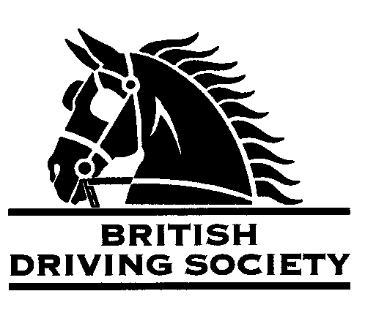
FOR ALL DRIVES HORSES MUST BE VACCINATED AGAINST EQUINE ‘FLU
APPROX. 15 MILE DRIVE, SHORTER ROUTE AVAILABLE, FROM BERRIEWOOD FARM. BRING PICNIC LUNCH.
THIS EVENT IS BEING RUN WITHIN HM GOVERNMENT GUIDELINES AS
LISTED UNDER WWW.GOV.UK

VENUE:BERRIEWOOD FARM EQUESTRIAN CENTRE
SHREWSBURY
POST CODE:
SY5 7NN

CODE:

DATE:SATURDAY
25TH SEPTEMBER 2021
TIME:ARRIVE FOR BRIEFING AT 10.30 AM
ENTRY FEE:
Member £5
Non Member £10

Maps and full instructions will be given at the commencement of the drive.

Neither the Organizing Committee, nor the British Driving Society, nor any Landowner, nor any Agent, Employee or representative of these bodies accept any responsibility for any accident, loss, damage, injury or illness to any animal, person or property whatsoever, however caused.
The Society takes reasonable precautions to ensure the Health and Safety of everyone present at each event. For these measures to be effective, everyone must take all reasonable precautions to avoid and prevent accidents occurring, and must obey the instructions of the Organizer and all Officials and Stewards.

Individuals should comply with Government guidelines regarding Covid 19 in place at the time. Hand sanitiser and wipes to be carried.
Individuals who are symptomatic or have been exposed to the virus should not attend.

All drivers and participants must agree to abide by the Rules of the British Driving Society available at www.britishdrivingsociety.co.uk
- Correctly fitted hard hats that meet the latest safety regulations are recommended and are mandatory for participants under the age of 14.
- All drivers must be aged 8 years or older and all participants under 18 must be accompanied by a responsible adult.
CLOSING DATE FOR ENTRIES 18TH SEPTEMBER 2021…………………………………………………….

Entry form for Event: ……………………………………………………… DRIVE on ……………………….………………….
NAME………………………………………………………………………………………………………………………………........................
ADDRESS………………………………………………………………………………………………………………………….......................
…………………………………………………………………………………………………………POST CODE…………………………………
TELEPHONE No…………………………………………........….......MOBILE................................…………………………
Email………………………………………………………………………………………………………………………………….......................
I am a B.D.S. MEMBER, Membership No. …………………………..……….. (complete as
I am not a BDS Member and have signed the Non Member Form…………………. applicable)
Payment enclosed……………………………………………………… …...(cheque payable to BDS Shropshire)
I confirm my horse is vaccinated against Equine ‘flu Please tick

SIGNED……………………………………………………PRINT……………………………………….......................................

Please return this slip with your cheque by 18TH SEPTEMBER 2021……………………
to…Felicity Stubbs Birch Tree Farm Knightley Stafford ST20 0JN
Enquiries…07572156438 -1785284140. ………………………………………………………………….

