BRITISH DRIVING SOCIETY, SHROPSHIRE AREA 27
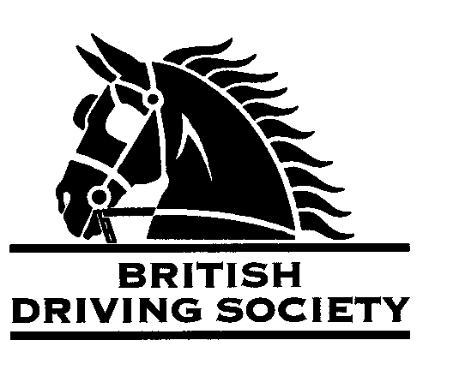
EVENT: FOR EQUINE ‘FLU VACCINATED HORSES ONLY.
THE CITADEL ROAD DRIVE FOLLOWED BY BRING YOUR OWN PICNIC. THIS EVENT IS BEING RUN WITHIN HM GOVERNMENT COVID 19 GUIDELINES THAT MAY BE IN PLACE AT THE TIME

VENUE: THE CITADEL, WESTON-UNDER-REDCASTLE, SHREWSBURY BY KIND PERMISSION OF MR AND MRS B GRIFFITHS.
Long route approx. 12 miles and Short route approx. 8 miles
POST CODE:
SY4 5JY

DATE: SUNDAY
19TH SEPTEMBER 2021
TIME: ARRIVE 10.00AM FOR INDIVIDUAL START FROM 11.00AM

ENTRY FEE:
Member £5
Non Member £10

Maps and full instructions will be given at the commencement of the drive.

Neither the Organizing Committee, nor the British Driving Society, nor any Landowner, nor any Agent, Employee or representative of these bodies accept any responsibility for any accident, loss, damage, injury or illness to any animal, person or property whatsoever, however caused.
The Society takes reasonable precautions to ensure the Health and Safety of everyone present at each event. For these measures to be effective, everyone must take all reasonable precautions to avoid and prevent accidents occurring, and must obey the instructions of the Organizer and all Officials and Stewards.

All drivers and participants must agree to abide by the Rules of the British Driving Society available at www.britishdrivingsociety.co.uk.
Individuals should comply with Government Guidelines regarding Covid 19 in place at the time. Hand sanitiser & wipes to be carried.
Individuals who are symptomatic or have been exposed to the virus should not attend.
Correctly fitted hard hats that meet the latest safety regulations are recommended and are mandatory for participants under the age of 14.
All drivers must be aged 8 years or older and all participants under 18 must be accompanied by a responsible adult.

CLOSING DATE FOR ENTRIES …..10th SEPTEMBER 2021………………………………………………………………….

Entry form for Event: THE CITADEL ON 19TH SEPTEMBER 2021
NAME………………………………………………………………………………………………………………………………………………………
ADDRESS…………………………………………………………………………………………………………………………........................
…………………………………………………………………………………………………………POST CODE………………………………….
TELEPHONE No…………………………………………........…......MOBILE................................………………………….
Email………………………………………………………………………………………………………………………………….......................
I am a B.D.S. MEMBER, Membership No. …………………………..………..
I am not a BDS Member and have signed the Non Member Form (delete as applicable)
Payment enclosed……………………………………………………….(cheque payable to BDS Shropshire)
I confirm my horse is vaccinated against Equine ‘flu Please tick

SIGNED……………………………………………………PRINT……………………………………….......................................
Please return this slip with your cheque by …10TH SEPTEMBER 2021……………… to:
MRS B E COWIE MILL HOUSE MILL LANE NESS NESTON WIRRAL CHESHIRE CH64 8TH
Enquiries tel…0151 336 2505……………………………………………………….

