BRITISH DRIVING SOCIETY, SHROPSHIRE AREA 27
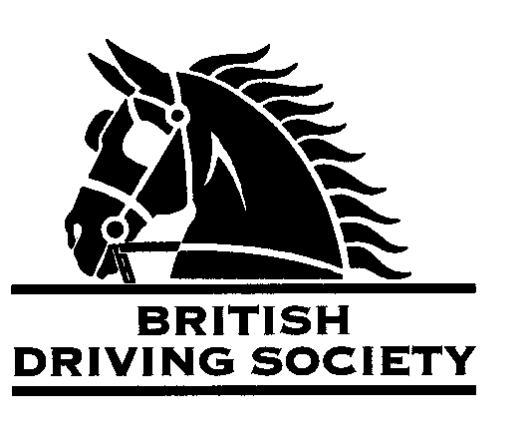
ECCLESHALL FUN DAY
WITH A SHORT DRIVE OF 3 MILES and fun on the field !

VENUE: Birch Tree Farm, Knightley, Stafford by kind permission of Felicity Stubbs & Family. Bring a picnic, tea & cake later!
All participants are required to follow government guidelines in respect of limiting the spread of Covid 19 - https://www.gov.uk/coronavirus

POST CODE:
ST20 0JN

ENTRY FEE:
Member £5.00
Non Member £10
DATE:
WEDNESDAY 11th AUGUST 2021.
START TIME:
Briefing at 10.30am

Neither the Organizing Committee, nor the British Driving Society, nor any Landowner, nor any Agent, Employee or representative of these bodies accept any responsibility for any accident, loss, damage, injury or illness to any animal, person or property whatsoever, however caused.
The Society takes reasonable precautions to ensure the Health and Safety of everyone present at each event. For these measures to be effective, everyone must take all reasonable precautions to avoid and prevent accidents occurring, and must obey the instructions of the Organizer and all Officials and Stewards.
All drivers at each Event must be BDS members, or to have signed a NON MEMBER FORM.
All participants must agree to abide by the Rules of the British Driving Society - available at www.britishdrivingsociety.co.uk
ONLY ENTRIES FROM HORSES VACCINATED AGAINST EQUINE INFLUENZA WILL BE ACCEPTED AT THIS EVENT.
- Correctly fitted hard hats that meet the latest safety regulations are recommended and are mandatory for participants under the age of 14.
- All drivers must be aged 8 years or older and all participants under 18 must be accompanied by a responsible adult.

CLOSING DATE FOR ENTRIES....................Sunday 8th August 2021
-----------------------------------------------------------------------------------------------------
Entry form for Event:...KNIGHTLEY DRIVE......................on 11th AUGUST 2021
In the event of a change in regulations, or a local lockdown, the ‘decision to run’ will be taken on 8.8.21
NAME………………………………………………………………………………………………………………………………..........................
ADDRESS…………………………………………………………………………………………………………………………........................
…………………………………………………………………………………………………………POST CODE………………………………….
TELEPHONE No…………………………………………........…..........MOBILE................................………………………
Email…………………………………………………………………………………………………………………………………......................... I am a B.D.S. MEMBER, Membership No. ……………………….Non member form attached(tick)
Payment enclosed……………………………………………………….
SIGNED……………………………………………………PRINT………………………………………..............
Please return this slip with your cheque, payable to B.D.S Shropshire, to:
Felicity Stubbs, Birch Tree Farm, Stafford, ST20 0JN...................before the Closing Date of 8.8.21 Please direct enquiries to: 01785 284140

