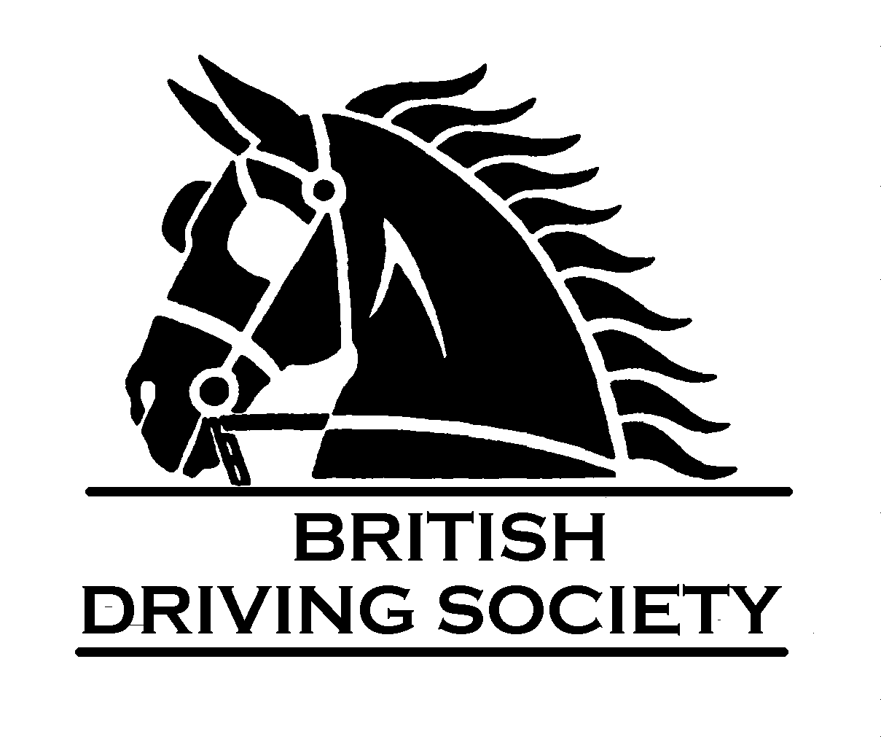

NON MEMBERS EVENT FORM
Event Organiser to ensure this is completed in full and signed by all Non Members participating in any British Driving Society Event before commencement of event.

Completed forms to be returned to BDS Office by event organiser.

NAME

ADDRESS

TELEPHONE NUMBER and
EMAIL ADDRESS

EVENT IN BDS AREA 27 | Easter Drive

[ ] I have read & agree to abide by the event rules:

[ ] I can confirm that I am not a member of the British Driving Society and I have up to date current Public Liability Insurance Cover, which I will produce evidence of as and when required by the BDS. I understand that I am responsible for the safe conduct of my turnout and will take all reasonable precautions to prevent an accident.

[ ] I also consent to the British Driving Society collecting my personal data for marketing purposes.
Please tick the appropriate boxes and sign below:

SIGNED…………………………………………….. DATE………………………….

PRINT NAME………………………………………………………………………….

